开通机构 | 绑定网址(此网址与二维码只作绑定学院用) | 绑定二维码
重庆大学外国语学院 | https://x.cnki.net/search/common/html/freeteam.html?orgInfo=U2iBBh8kbVGMGTtlJDrs7myLHot74keT8uTt%2f3g6VnvRi%2bqpMxYcaZaSyLAKOhhnLyi8oDNEjn%2btnN1GA1gunv%2fYx3W10aTBPuk%3d | 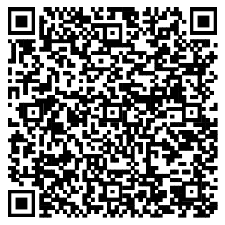
重庆大学国际学院 | https://x.cnki.net/search/common/html/freeteam.html?orgInfo=U2iBBh8kbVGMGTtlJDrs7myLHot74kRklN5tD8cyP%2fshRWgbkA5FO9NEdhFesjt%2beDO3%2fKudauOC2ZXvSZtEFoANCEi10aTBPuk%3d | 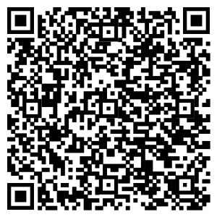
重庆大学弘深学院 | https://x.cnki.net/search/common/html/freeteam.html?orgInfo=U2iBBh8kbVGMGTtlJDrs7myLHot74kU2qYPlAA5epZYqgozxKlfeGsez1AlEtjAbVUQwuJITHJxG8EaPxVUwhiGascydvoAP4uA%3d | 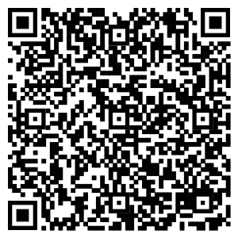
重庆大学博雅学院 | https://x.cnki.net/search/common/html/freeteam.html?orgInfo=U2iBBh8kbVGMGTtlJDrs7myLHot74kKL43SS2YiL1PshRWgbkA5FO9NEdhFesjt%2beDO3%2fKudauOC2ZXvSZtEFoANCEi10aTBPuk%3d | 
重庆大学人文社会科学高等研究院 | https://x.cnki.net/search/common/html/freeteam.html?orgInfo=U2iBBh8kbVGMGTtlJDrs7myLHot74kNVBBs0yYyDvddz53EijHHgk5aSyLAKOhhnLyi8oDNEjn%2btnN1GA1gunv%2fYx3W10aTBPuk%3d | 
重庆大学公共管理学院 | https://x.cnki.net/search/common/html/freeteam.html?orgInfo=U2iBBh8kbVGMGTtlJDrs7myLHot74kAuWiE72IyDvddz53EijHHgk5aSyLAKOhhnLyi8oDNEjn%2btnN1GA1gunv%2fYx3W10aTBPuk%3d | 
重庆大学经济与工商管理学院 | https://x.cnki.net/search/common/html/freeteam.html?orgInfo=U2iBBh8kbVGMGTtlJDrs7myLHot74kH443SS2YiL1PshRWgbkA5FO9NEdhFesjt%2beDO3%2fKudauOC2ZXvSZtEFoANCEi10aTBPuk%3d | 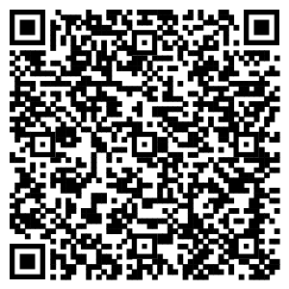
重庆大学新闻学院 | https://x.cnki.net/search/common/html/freeteam.html?orgInfo=U2iBBh8kbVGMGTtlJDrs7myLHot74k50%2b25ygP7Bf8O9L7Eqn7LzeWXs36Haugi2zlZrU79rK6ITZP%2bdJd6Ms8EuhZaY9BtW%2fKs%3d | 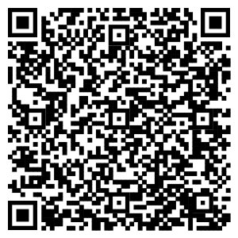
重庆大学法学院 | https://x.cnki.net/search/common/html/freeteam.html?orgInfo=U2iBBh8kbVGMGTtlJDrs7myLHot74k8GJWT93t4iXNuebNUAhAayv8u7w%2bpveEoiZIWG4f2FrQlO4YkyxVUwhiGascydvoAP4uA%3d | 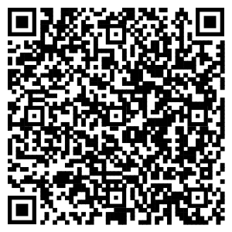
重庆大学马克思主义学院 | https://x.cnki.net/search/common/html/freeteam.html?orgInfo=U2iBBh8kbVGMGTtlJDrs7myLHot743T8%2br92Gy06VnvRi%2bqpMxYcaZaSyLAKOhhnLyi8oDNEjn%2btnN1GA1gunv%2fYx3W10aTBPuk%3d | 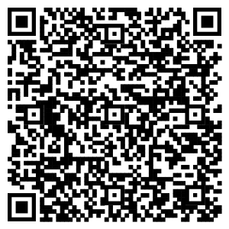
重庆大学数学与统计学院 | https://x.cnki.net/search/common/html/freeteam.html?orgInfo=U2iBBh8kbVGMGTtlJDrs7myLHot743WP%2br92Gy06VnvRi%2bqpMxYcaZaSyLAKOhhnLyi8oDNEjn%2btnN1GA1gunv%2fYx3W10aTBPuk%3d | 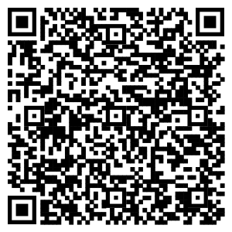
重庆大学物理学院 | https://x.cnki.net/search/common/html/freeteam.html?orgInfo=U2iBBh8kbVGMGTtlJDrs7myLHot743ZZ77tpVE3ZcWUxslCZpz9NK2TxBiwfXZ98skLCKDOkelJV8EaPxVUwhiGascydvoAP4uA%3d | 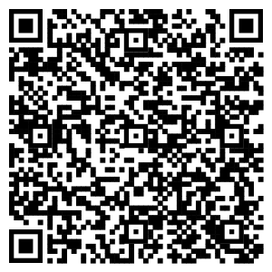
重庆大学化学化工学院 | https://x.cnki.net/search/common/html/freeteam.html?orgInfo=U2iBBh8kbVGMGTtlJDrs7myLHot743do7I%2bT6GhepZYqgozxKlfeGsez1AlEtjAbVUQwuJITHJxG8EaPxVUwhiGascydvoAP4uA%3d | 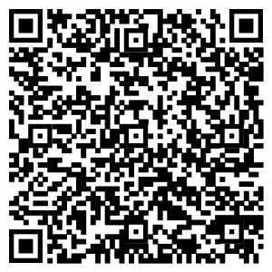
重庆大学生命科学学院 | https://x.cnki.net/search/common/html/freeteam.html?orgInfo=U2iBBh8kbVGMGTtlJDrs7myLHot743CH6w%2bClw4%2bXkjpXXbqSsiDksivXG6L%2b9lV0azYPPrDfkq%2bPhPcZYC%2bfLF1BafF%2buccN0k%3d | 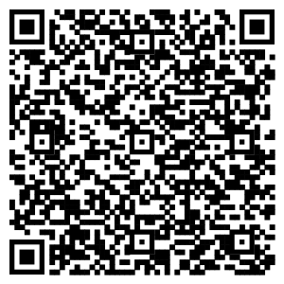
重庆大学建筑城规学院 | https://x.cnki.net/search/common/html/freeteam.html?orgInfo=U2iBBh8kbVGMGTtlJDrs7myLHot743FRDDNpVE3ZcWUxslCZpz9NK2TxBiwfXZ98skLCKDOkelJV8EaPxVUwhiGascydvoAP4uA%3d | 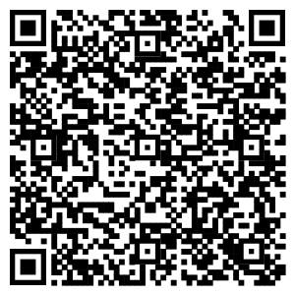
重庆大学土木工程学院 | https://x.cnki.net/search/common/html/freeteam.html?orgInfo=U2iBBh8kbVGMGTtlJDrs7myLHot743JgnPErtlz53AVUxrx0txkvN8yXnuK3ytdmvngVEcNhnIzXTjx5dVHJ3ARltCWIiPD3%2bLI%3d | 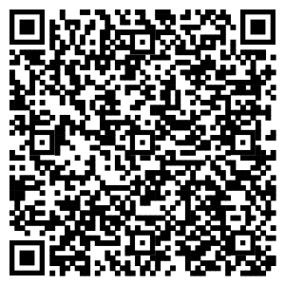
重庆大学机械工程学院 | https://x.cnki.net/search/common/html/freeteam.html?orgInfo=U2iBBh8kbVGMGTtlJDrs7myLHot743MyUV%2bClw4%2bXkjpXXbqSsiDksivXG6L%2b9lV0azYPPrDfkq%2bPhPcZYC%2bfLF1BafF%2buccN0k%3d | 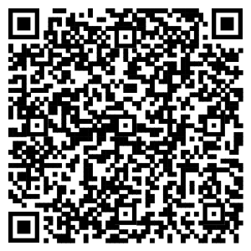
重庆大学电气工程学院 | https://x.cnki.net/search/common/html/freeteam.html?orgInfo=U2iBBh8kbVGMGTtlJDrs7myLHot743xw43SS2YiL1PshRWgbkA5FO9NEdhFesjt%2beDO3%2fKudauOC2ZXvSZtEFoANCEi10aTBPuk%3d | 
重庆大学能源与动力工程学院 | https://x.cnki.net/search/common/html/freeteam.html?orgInfo=U2iBBh8kbVGMGTtlJDrs7myLHot7430CLT8GM7Q6d%2fIjvnEijHHgk5aSyLAKOhhnLyi8oDNEjn%2btnN1GA1gunv%2fYx3W10aTBPuk%3d | 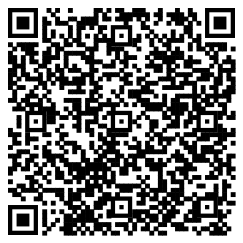
重庆大学资源与安全学院 | https://x.cnki.net/search/common/html/freeteam.html?orgInfo=U2iBBh8kbVGMGTtlJDrs7myLHot74OmrIfiK6iabKlyOP3bqSsiDksivXG6L%2b9lV0azYPPrDfkq%2bPhPcZYC%2bfLF1BafF%2buccN0k%3d | 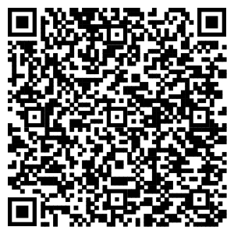
重庆大学材料科学与工程学院 | https://x.cnki.net/search/common/html/freeteam.html?orgInfo=U2iBBh8kbVGMGTtlJDrs7myLHot74OiZPslknwXxpCBXYLRc%2bPX43ZKqpmKoKqu8%2fCr6JDtzqAe8%2fFBYzkI6ZPPhrCstGT1%2f2Fk%3d | 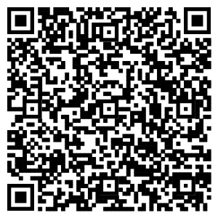
重庆大学航空航天学院 | https://x.cnki.net/search/common/html/freeteam.html?orgInfo=U2iBBh8kbVGMGTtlJDrs7myLHot74OsEAOzynyUqIZnRi%2bqpMxYcaZaSyLAKOhhnLyi8oDNEjn%2btnN1GA1gunv%2fYx3W10aTBPuk%3d | 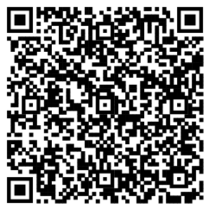
重庆大学汽车工程学院 | https://x.cnki.net/search/common/html/freeteam.html?orgInfo=U2iBBh8kbVGMGTtlJDrs7myLHot74Op1ShOL%2bNeDvddz53EijHHgk5aSyLAKOhhnLyi8oDNEjn%2btnN1GA1gunv%2fYx3W10aTBPuk%3d | 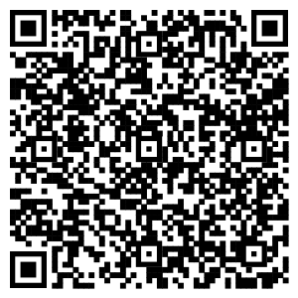
重庆大学辛辛那提大学联合学院 | https://x.cnki.net/search/common/html/freeteam.html?orgInfo=U2iBBh8kbVGMGTtlJDrs7myLHot74O3hY2TdzsLs2lA08bu0vwlcLp79fbAKOhhnLyi8oDNEjn%2btnN1GA1gunv%2fYx3W10aTBPuk%3d | 
重庆大学环境与生态学院 | https://x.cnki.net/search/common/html/freeteam.html?orgInfo=U2iBBh8kbVGMGTtlJDrs7myLHot74OzW1ftINf7Bf8O9L7Eqn7LzeWXs36Haugi2zlZrU79rK6ITZP%2bdJd6Ms8EuhZaY9BtW%2fKs%3d | 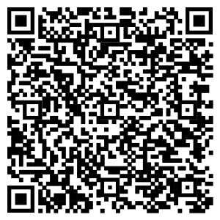
重庆大学管理科学与房地产学院 | https://x.cnki.net/search/common/html/freeteam.html?orgInfo=U2iBBh8kbVGMGTtlJDrs7myLHot74O9Czq9RM5OzXihGV%2by%2f%2bze6r1xxFp2R2ZaWk5K4uJITHJxG8EaPxVUwhiGascydvoAP4uA%3d | 
重庆大学光电工程学院 | https://x.cnki.net/search/common/html/freeteam.html?orgInfo=U2iBBh8kbVGMGTtlJDrs7myLHot74O6zMGkrtlz53AVUxrx0txkvN8yXnuK3ytdmvngVEcNhnIzXTjx5dVHJ3ARltCWIiPD3%2bLI%3d | 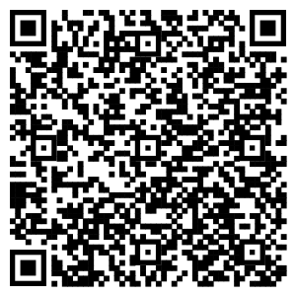
重庆大学微电子与通信工程学院 | https://x.cnki.net/search/common/html/freeteam.html?orgInfo=U2iBBh8kbVGMGTtlJDrs7myLHot74OE0hdpE0aTMj1A08bu0vwlcLp79fbAKOhhnLyi8oDNEjn%2btnN1GA1gunv%2fYx3W10aTBPuk%3d | 
重庆大学计算机学院 | https://x.cnki.net/search/common/html/freeteam.html?orgInfo=U2iBBh8kbVGMGTtlJDrs7myLHot74OBlazz93t4iXNuebNUAhAayv8u7w%2bpveEoiZIWG4f2FrQlO4YkyxVUwhiGascydvoAP4uA%3d | 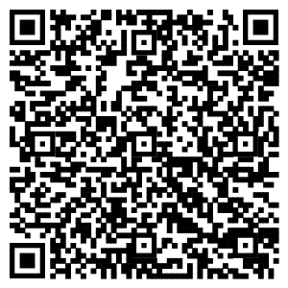
重庆大学自动化学院 | https://x.cnki.net/search/common/html/freeteam.html?orgInfo=U2iBBh8kbVGMGTtlJDrs7myLHot74ZdtWsG3lFX00PIjvnEijHHgk5aSyLAKOhhnLyi8oDNEjn%2btnN1GA1gunv%2fYx3W10aTBPuk%3d | 
重庆大学大数据与软件学院 | https://x.cnki.net/search/common/html/freeteam.html?orgInfo=U2iBBh8kbVGMGTtlJDrs7myLHot74ZaiY0QeVG0yP%2fshRWgbkA5FO9NEdhFesjt%2beDO3%2fKudauOC2ZXvSZtEFoANCEi10aTBPuk%3d | 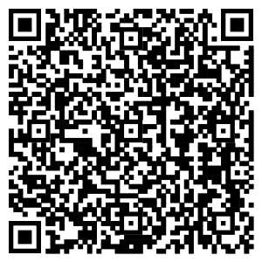
重庆大学医学院 | https://x.cnki.net/search/common/html/freeteam.html?orgInfo=U2iBBh8kbVGMGTtlJDrs7myLHot74ZWQf4plEF1WcoX2UpUYpa%2bS8QYz5P7augi2zlZrU79rK6ITZP%2bdJd6Ms8EuhZaY9BtW%2fKs%3d | 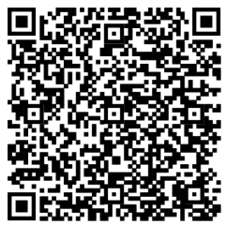
重庆大学药学院 | https://x.cnki.net/search/common/html/freeteam.html?orgInfo=U2iBBh8kbVGMGTtlJDrs7myLHot74ZTB3n3QNK%2fJlkOt8eRmA5Vs%2bhaC7M9swdG9bZqp%2bLO0641G8EaPxVbjs8EuhZaY9BtW%2fKs%3d | 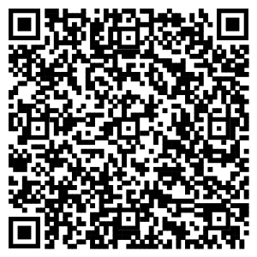
重庆大学生物工程学院 | https://x.cnki.net/search/common/html/freeteam.html?orgInfo=U2iBBh8kbVGMGTtlJDrs7myLHot74ZM3GFVtD8cyP%2fshRWgbkA5FO9NEdhFesjt%2beDO3%2fKudauOC2ZXvSZg5RLV9dvPronIkIyc%3d | 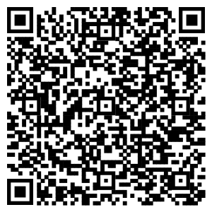
重庆大学重大城市科技学院 | https://x.cnki.net/search/common/html/freeteam.html?orgInfo=U2iBBh8kbVGMGTtlJDrs7myLHot74ZJktIRZIvbxpCBXYLRc%2bPX43ZKqpmKoKqu8%2fCr6JDtzqAe8%2fFBYzkELx7F1BafF%2buccN0k%3d | 

